caMOD API
caBIG compliance
Version 1.0

Common Persistence eQBE

The hibernate.eqbe package contains classes in support of eQBE (Enhance Query-By-Example) querying. Please refer to the “Using eQBE” section of this document for usage of this object based mechanism.

The primary API for eQBE is EQBESession that provides the methods for creating eQBE based Hibernate criteria chains. (An understanding of the Hibernate Criteria API can be found in the Hibernate reference documents mentioned in the References section of this document).

EQBESession is based on a singleton factory pattern along with a base class, EQBESession, implementing class, EQBESessionImpl, and factory class, EQBESessionFactory.

The primary logic of eQBE is found in the EQBECriteria class. This is the primary class responsible for parsing the object graph based on the example object being queried and creating the necessary Hibernate Criteria and Criterion objects for execution by the underlying Hibernate API.

The Evaluation class is a container class for capturing the various Evaluator objects that can be applied to the properties of an example query object. The Evaluator objects themselves provide the syntax and mapping to the Hibernate Restriction API for eventually mapping to the underlying database.

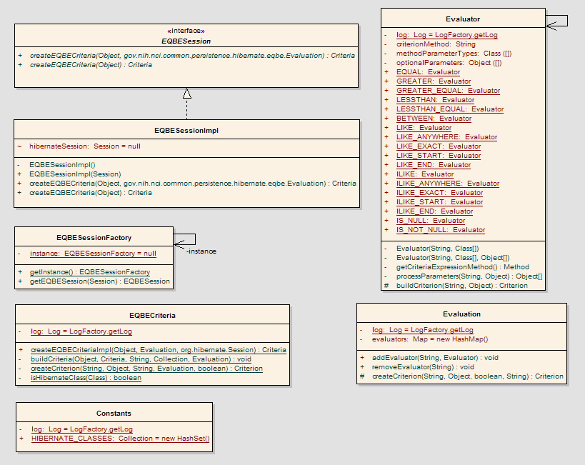
Figure 1 - eQBE Package

Configuration
Common Persistence configuration is based upon the O-R mapping configuration of Hibernate v3.x. Common Persistence requires hibernate mapping files (*.hbm.xml) and hibernate configuration files (hibernate.properties, hibernate.cfg.xml) to be implemented and locatable in the application context class path. An understanding of Hibernate O-R Mapping and configuration is required. Please refer to Hibernate 3.x documentation for details on these configuration files. (http://www.hibernate.org/hib_docs/reference/en/html/mapping.html.

All mapping files must be defined in the “hibernate.cfg.xml” file. A corresponding database schema must be implemented along with connectivity to your database configured in the “hibernate.properties” file. It is recommended to generate the schema directly from the Hibernate mapping files using the HBM2DDL hibernate tool. (http://www.hibernate.org/hib_docs/reference/en/html/toolsetguide.html#toolsetguide-s1)

    - Required JARs

In addition to the Common Persistence jar file (common-persistence.jar), the following jar files are required:
- hibernate3.jar
- commons-beanutils.jar
- log4j-1.2.8.jar
- odmg-3.0.jar
- jstl.jar
- cglib-full-2.0.2.jar
- commons-collections-3.1.jar
- dom4j-1.4.jar
- ehcache-0.9.jar
- commons-logging-1.0.4.jar
- (your JDBC driver, i.e. mysql-connector-java-3.1.6-bin.jar)

How to eQBE
The basic concept of eQBE is centered on a “target object”, meaning the root object of the query. Objects of the target object type will be returned in the result list based upon the criteria set within the properties of the target object, or any associated objects of the target object. These associations to the root object, along with associations to other objects of to themselves, make up what is called the “object graph”. All property values of every object in the object graph will be used as criteria for the query.

Example:

Given the following Class declarations:

Class Person {
Name name;
}

Class Name {
String firstName;
String lastName;
}
With eQBE we can query properties of member objects as follows.

Person examplePerson = new Person();
Name exampleName = new Name();
examplePerson.setName(exampleName);
examplePerson.getName ().setFirstName(“Max”);

List persons = Search.query(examplePerson);

The result List of persons will include all Person objects whose associated Name object has a firstName property value set to “Max”.

By default, Search.query (as above, without an Evaluation object) will apply an equals evaluation to the property values. (See notes below on case-sensitivity).

    - Applying Property Evaluation

Adding Evaluation criteria to the query provides a mechanism to evaluate property values at a fine-grained level.

For example, continuing with the previous example, we can apply a SQL type “like” evaluator to our search.

examplePerson.getName().setFirstName(“Max%”);

Evaluation evaluation = new Evaluation();
evaluation.addEvaluator(“name.firstName”, Evaluator.LIKE);

List persons = Search.query(examplePerson, evaluation);

As you can guess, this will give you all person objects with first names starting with “Max”.

Additionally, property values of “%Max%”, “%Max”, and “M_x”, all work as you’d expect, following ANSI-SQL wildcard standards.

Also, notice the object dot notation for the property name “name.firstName” when applying the Evaluator.

The Evaluator API documents all available Evaluators.

Another to point out is the “BETWEEN” Evaluator, which uses the syntax of “lower..higher”, for example:

object.anyYear = “1995..2002”;
evaluation.addEvaluator(“anyYear”, Evaluator.BETWEEN);

    - Applying Logical Operator

A property value can also contain an ‘OR’ logical operator.

Example:

person.getName().setFirstName(“Max||John||Mary”);

As you can probably guess, the firstName property will be evaluated against “Max”, “John”, and “Mary”.

    - Case Sensitivity and Null with eQBE

A note about evaluations in general is that ultimately ALL evaluations become SQL query statements. Hence, evaluation rules of the under-lying database apply to all evaluations. For example, by nature queries in MySQL are case-insensitive. The default equals behavior, and the Evaluator.EQUAL, Evaluator.LIKE, Evaluator.ILIKE will all therefore be case-insensitive. Hence, in the MySQL case, Evaluator.LIKE and Evaluator.ILIKE have identical behavior. However, if the underlying database for example is has case-sensitive support, such as Postgres, these Evaluators will behave to reflect the underlying database, Evaluator.LIKE will be case-sensitive and Evaluator.ILIKE will be case-insensitive.

Also, it is important to keep in mind is how to handle Null. Since java primitive types can NOT be set to Null, they will default to a value, for example, int will default to 0. Since by default eQBE will then search for a matching property, this needs to be accounted for in querying. First, it’s probably not a good idea to use primitive types in your Bean objects, but, if you must, keep in mind that java primitive type properties will ONLY be evaluated if a matching Evaluator is set on the property, meaning the default equals behavior does not apply.

Also, when using Evaluator.IS_NULL and Evaluator.IS_NOT_NULL evaluators, any value set in corresponding property is insignificant and ignored, the Null check will be applied, over-riding any property value set.

Using caCORE SDK generated data access API

We did not use the core SDK for generation of our domain objects and mappings for the following reasons:
- SDK was being developed at the same time as caMOD was being refactored, and was not in a stable state for use.
- Distributed query interface was deemed to be too expensive.
- It was deemed harder to understand the mappings in the EA tool. Understanding of the domain model and the ability to tune the mappings was achieved by doing the mappings by hand.

    - Issues w/ the mapping w/ current EA model:

An attempt was made to use the caCORE API generation tool for the current caMOD OM and hibernate mapping files. These are the findings:

- All domain objects need to have an ID parameter as the unique key; ours have <table_name>_id as the id.
- Equals implementation of the objects possibly not robust enough. For example, the equals implementation for a SexDistribution object:

public boolean equals(Object obj){
boolean eq = false;
if(obj instanceof SexDistribution) {
SexDistribution c =(SexDistribution)obj;
Long thisId = getId();
if(thisId != null && thisId.equals(c.getId())) {
eq = true;
}
}
return eq;
}

From the hibernate.org website:

“The most obvious way is to implement equals()/hashCode() by comparing the identifier value of both objects. If the value is the same, both must be the same database row, they are therefore equal (if both are added to a Set, we will only have one element in the Set). Unfortunately, we can't use that approach. Hibernate will only assign identifier values to objects that are persistent, a newly created instance will not have any identifier value! We recommend implementing equals() and hashCode() using “Business key” equality.

Business key equality means that the equals() method compares only the properties that form the business key, a key that would identify our instance in the real world (a natural candidate key).”

Additionally, the first equality comparison should be through Object equality.

- Domain object generation does not generate a specific error message, but instead simply fails. This makes changing the object model very tedious, and forces a “trial and error” approach to fixing any mapping problems.
- No support for interfaces. For example, the AnimalModel class in caMOD implements the Curatable interface.

public interface Curateable extends Serializable {
public String getState();
public void setState(String state);
}

- Seems to be optimized for read-only API’s. For example, the getHistopathologyCollection method in the AnimalModel class:

public java.util.Collection getHistopathologyCollection() {
try {
if (histopathologyCollection.size() == 0) {
}
} catch (Exception e) {
ApplicationService applicationService =
ApplicationService.getApplicationService();
try {

gov.nih.nci.camod.domain.AnimalModel thisIdSet = new
gov.nih.nci.camod.domain.impl.AnimalModelImpl();
thisIdSet.setId(this.getId());
java.util.Collection resultList =
applicationService.search(
"gov.nih.nci.camod.domain.Histopathology",
thisIdSet);
histopathologyCollection = resultList;
return resultList;

} catch (Exception ex) {
System.out.println("<error message>");
ex.printStackTrace();
}
}
return histopathologyCollection;
}
If the histopathologyCollection already exists, no exception will be thrown and the data will not be re-queried.

- If changes/domain logic need to be added to the objects, how do we preserve this if we regenerate the code? For example, in the Organ object we have the following domain logic:

/**
* @return Returns the EVS Preferred displayName
*/
public String getEVSPreferredDescription() {
return EvsTreeUtil.getEVSPreferedOrganDescription(conceptCode);
}

This is business logic code that would be lost during code regeneration.

Projected caMOD API

Changes to the read-only API
- A remote interface will need to be added to the read only interface. We will need to take into account the “writeable” nature of our data.

Possible Implementation of a remote writeable API
There are many considerations to take into account when designing a remote writeable API. For example:

- Remote transactions
- User login/security privileges; How do we keep a user from changing models that they don’t own?
- If a fine grained API is exposed, the OM can be quite complex.
- Controlled vocabularies/values for certain fields. How do we get that information to the user?
- For the controlled vocabularies how do we limit the user to only the allowed values?

We propose to deal with these most of these issues by remote proxies around the managers developed to support the back end save/update processing for our web application. We will also need to have some sort of login API which provides the remote user with a criteria object that can be used for a certain amount of time.
In addition, the remote manager API will have “helper” classes which will encapsulate the data and controlled vocabulary for each coarse grained method on the remote manager.

For example, the following is an idea of how the code might look when adding a Therapy object to an AnimalModel:

Credentials theCred = ApplicationInterface.login(“dave”, “password”);

AnimalModel theQBEAnimalMode = new AnimalModel();
theQBEAnimalModel.setModelDescriptor(“testmodel”);

List theList = SearchProxy.query(theQBEAnimalModel);

if (theList.size() > 0)
{
AnimalModel theAnimalModel = (AnimalModel) theList.get(0);

ViralTreatmentData theViralData = new ViralTreatmentData();
theViralData.setName(“A-MuLV (Abelson murine leukemia virus)”);
theViralData.setGender(“Male Only”);

AnimalModelManagerProxy.addTherapy(
theCred, theAnimalModel, theViralData);
}

The issues raised are addressed as follows:

- The AnimalModelManagerProxy addTreatment call would be processed as a separate transaction on the back end. No remote transactions spanning multiple calls would be necessary
- We would have a login method which would return some sort of credentials object that would need to be passed in to all methods which modify data.
- The ViralTreatmentData object would have a field for any data that is necessary for adding a Therapy object. This object would also verify that all required fields had been set as well as supplying any “controlled” vocabularies. For example, the getPossibleNames() might return a list of all viral treatments which are valid for this object.
- Instead of creating a Therapy object, setting it’s name, creating a SexDistribution object and associating it to the Therapy object and then adding the Therapy object to the AnimalModel object, this work is done by the back end.

